MADHVIRAJE NURSING COLLEGE
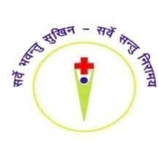
A.B. Road, Near Warehouse, Banmore Kalan, District-Morena (M.P.) 476444
Ph.No. 07773014421 & E-Mail - mrnc2006@rediffmail.com

CODE OF ETHICS
15.04.2021

3.3.1 The institution has a stated Code of Ethics to check malpractices and plagiarism in Research

We have the access to the well known plagiarism detecting software called “Plagiarism Checker X”. Before sending the research manuscript, the Research committee will take the responsibility to check and reduce the plagiarism level, if needed. In recent years, journals/reputed conferences will have the access to the famous plagiarism detection tool known as Plagiarism Checker X and the journals/conferences will help the authors to check the similarity level, before the manuscript is processed. The above said procedures will help the authors to publish high quality research works in reputed journals/conferences/books with an allowable as well as lesser level of plagiarism. All the manuscripts submitted to the journal/conference/book by the department staff is initially screened by the Plagiarism Checker X software and the possible similarity issues are fixed by the authors. Further, the institute deplores and discourage the violation of code of ethics which is dishonest and immoral infringing the copyrights act of intellectual property rights. Further, the national and international conference proceedings published by the college will be checked with Plagiarism Checker X to avoid the plagiarism.
